These organizations guide the Forest Stewardship Program in the U.S. Virgin Islands

Agriculture, Division of Forestry
U.S. Virgin Islands Department of Planning and Natural Resources, Division of Environmental Protection
U.S. Department of Agriculture, Forest Service/International Institute of Tropical Forestry, Natural Resources Conservation Service, and the Farm Services Agency
U.S. Fish and Wildlife Service
University of the Virgin Islands, Cooperative Extension Service and Agricultural Experiment Station
St. Croix Environmental Association
The Nature Conservancy
This publication made possible through a grant from the USDA Forest Service.
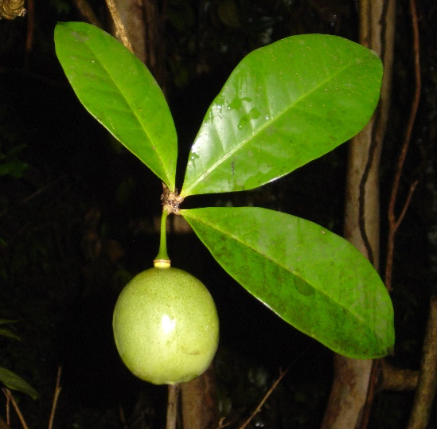

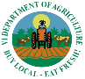

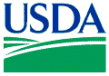

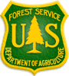

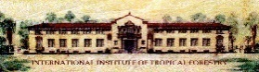

THE US VIRGIN ISLANDS

FOREST STEWARDSHIP PROGRAM
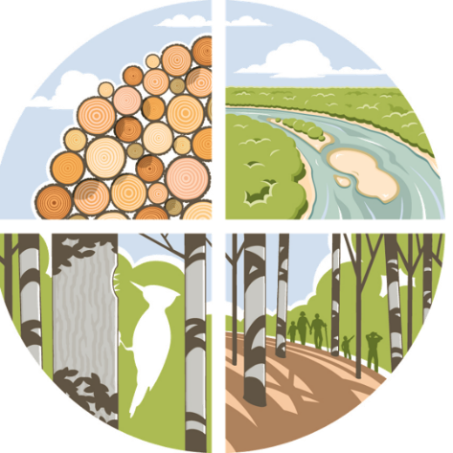

Helping landowners improve forested land in the US Virgin Islands
Regeneration of Natural Forests
Sustainable Forestry
Fertile Soil
Clean Water
Enhanced Aesthetics
Wildlife Habitat
Historical Preservation
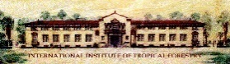
Improved Recreation

Introduction
The Forest Stewardship Program is a program that assists private landowners in managing their forested land for specific objectives, including:
- Protection of soil from erosion and water from pollution (this is a mandatory objective for all management plans);
- Production of forest and non-forest products such as timber, fruits, and other agricultural corps;
- Providing habitat for wildlife and plants, such as migratory birds, pollinators, native trees;
- Management of forest health to reduce and manage disease, invasive plant species, and destructive fires;
- Recognition of forested lands that contain significant historic and cultural sites;
- Improved recreational opportunities for landowners and/or the public; and
- Enhancement of natural forest beauty.
In accordance with Federal law and U.S. Department of Agriculture policy, this institution is prohibited from discriminating on the basis of race, color, national origin, sex, age, or disability. To file a complaint of discrimination, write USDA, Office of Civil Rights, Room 326-W, Whitten Building, 1400 Independence Ave., SW, Washington, D.C. 20250-9410 or call (202) 720-5964 (voice and TDD). USDA is an equal opportunity provider and employer.
Eligibility
The Forest Stewardship Program is open to private landowners (individuals, families, and corporations) that meet the following criteria:
- Must own (or have a long-term lease on) at least three (3) acres of forested land, or own (or have a long-term lease on) land that is to be reforested as part of a management plan;
- Applicant must be able to commit to a management plan of at least 10 years in duration;
- Property must not have any other natural resources management plan in place; and
- Landowner is asked to sign a non-binding, good faith agreement to implement the management plan as part of being a forest steward.*
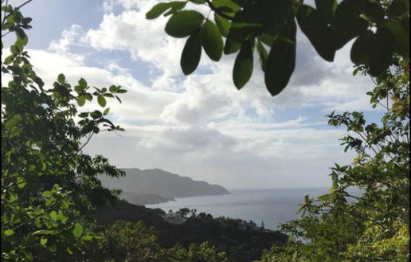
*The Forest Stewardship Program is a voluntary program. The forest management plan is a guideline for forest improvement, not a legally binding contract.
Benefits
- Sustainable production of various forest and non-forest products
- Fertile soils for production and biodiversity
- Higher property values with improved aesthetics
- Overall water quality improvement
- Healthy forests with regeneration of natural forest (weed removal)
- Reduction in property taxes if plan is implemented
- Enhanced recreation opportunities
- Cost share programs are available from the federal government for implementation of plans
- Landowners who demonstrate good stewardship receive certificates for their efforts, and a “Stewardship Forest” sign to post on the property
Questions?
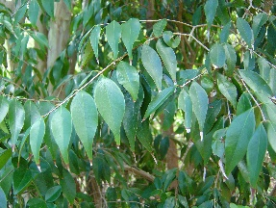
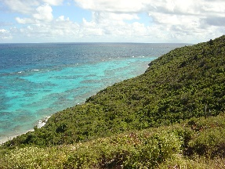
Contact the USVI Forest Stewardship Coordinator M. Wilson at 778-0997

